**NS Academy Code Challenge**

The yacht harbour association (TYHA) is need of a system to track the coming and going of boats in their marinas. They have enlisted your assistance.

The code produced should consider and demonstrate object oriented design principals. Where possible Test Driven Development should be used as a development method.

After each Stage you should commit your code to GIT, commenting on the stage it is and what you have done.

If you cannot use GIT then for each stage, save a copy of the Java files produced up until that point into a folder called **stage_x**, where x is the stage number. E.g. after completing **stage 1**, save the files to a folder called **stage_1**.

**Stage 1**

Create a Person Object. Each person must have a **first name**, **surname, date of birth**, **nationality**. If they are not from the UK they may also have another attribute called **visa information**.

**Stage 2**

Secondly, create a Marina object. Each marina will need to store a number of boats depending on size and requirements.

**Stage 3**

Next create a Boat object. Each boat will have a **name**, **country of origin** and **size**. Boats must implement the following interface.

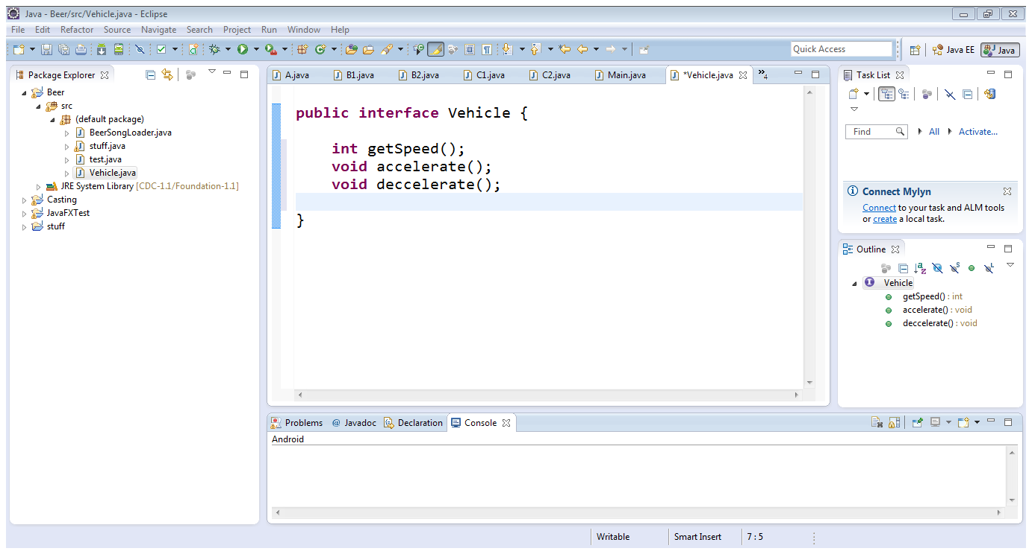

**Stage 4**

Each boat must have at least person associated with it before it is allowed to enter a marina. A person can be in the role of Owner, Captain or Crew. A boat can have multiple owners or crew but only ever one captain. A person can be an owner and crew or an owner and captain but not captain and crew. A boat is allowed into port with any one person associated.

A marina cannot have more boats than space. A boat cannot be at more than one marina at once.

**Stage 5**

Write a java application to read in the data file stage_5_input.txt and construct the appropriate Java objects.

The stage_5_input.txt file can be located in the same directory as the Java application.

Include a text file that explains how to compile and run your program.

It should handle an exception if the file is not there.

**Stage 6**

Once the file in stage 5 has been read in and objects constructed so that there is a collection of people, boats and marinas add additional code to associate the following objects together.

Boaty McBoatface captained by Peter Jackson

Boaty McBoatface owned by Emma Watson

Boaty McBoatface crewed by Adele Ginger

Boaty McBoatface crewed by Avril Lavigne

Boaty McBoatface crewed by Brian Johnson

Santa Maria crewed by Peter Jackson

Mary’s dream owned by Mary Jones

Aquaholic Captained by Linus Torvalds

Aquaholic owned by Bill Knightley

Aquaholic owned by David Green

Aquaholic moored at Venice

Mary’s dream moored at Monaco

Boaty McBoatface moored at Monaco

Santa Maria moored at Venice

**Stage 7**

Using the objects and data structures that have been created and populated, now perform some analysis on the data and output the answers to the console.

1. Who is the oldest person at each port?
2. How many boats are at each port?
3. Add a boat from one marina to another.
4. Deliver a map of all the boats in a marina.
5. Produce a report of all of the people in harbour at the current time ordered by boat.

**Stage 8**

Describe the object oriented design features that have been included in the Java code produced. What advantages does this give the code and how does it help support future extensions to the code if new requirements were defined.